DLD MINI PROJECT

**GROUP MEMBERS**

1. Muhammad Murad 21K-3064
2. Fawaz Ahmed 21K-4717
3. Khadija Ibrahim 21K-3054
4. Ausaf Ur Rehman 21K-3101

**PROJECT OBJECT**

To indicate water level of the bottle and to prevent overflow

**COMPONENTS**

1. NE555 Timer
2. Resistors
   1. R1,R4-1K
   2. R2-22k
   3. R3-570 Ohm
3. Capacitor- 1UF
4. Buzzer
5. Connecting wires

**CIRCUIT DIAGRAM**

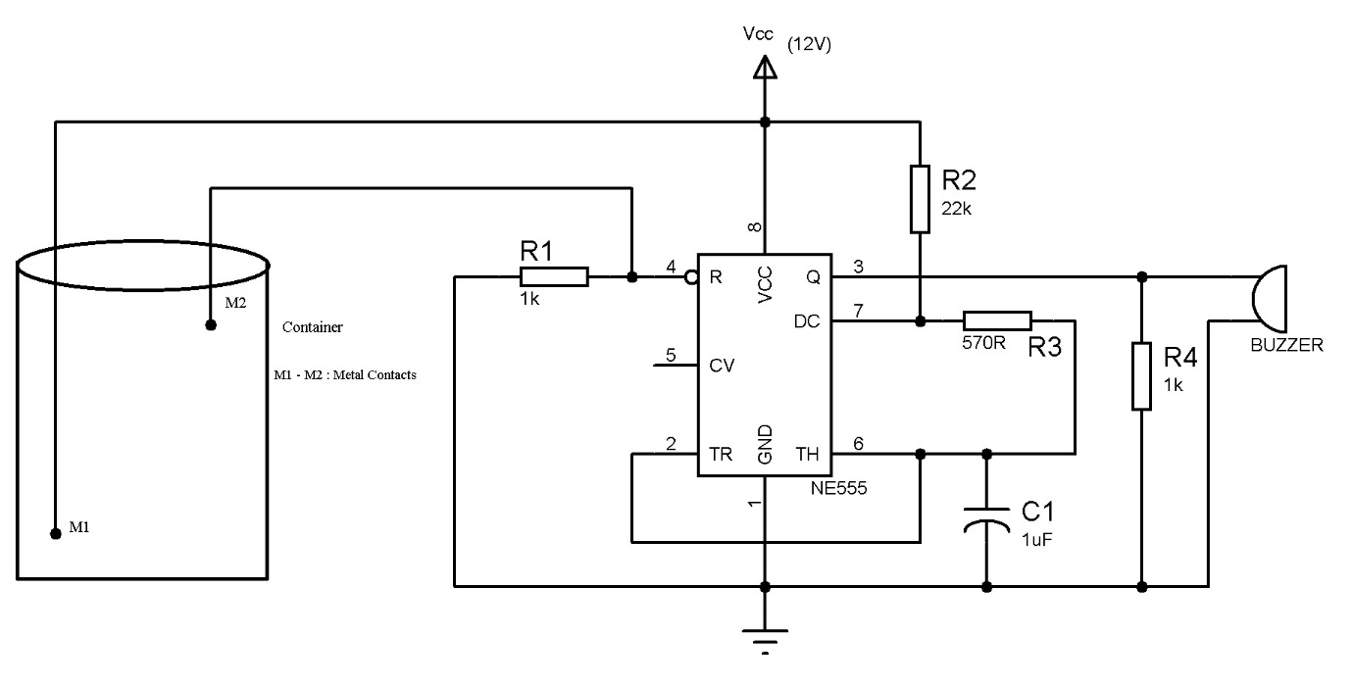

**DESCRIPTION**

The circuit uses a 555 timer in astable mode with R1=22k ohms, R2= 570 ohms and C1=1 uF. The frequency of the given astable circuit is around 62 Hz.

The two probes which are shown in the circuit should be kept at the high level for the water. The distance between the probes should be less than a few centimetres to ensure that the conduction between the probes will take place when water is touched to these probes.

When the water level rises to the height of the probes, then the 555 circuit will get enabled and the output of the 555 timer produces a square wave output with a frequency of about 62 Hz. This output is given to the buzzer.

The logic Implemented in this circuit is, 555 timer is enabled when its reset pin is connected to logic high. But initially it is connected to ground. When the water level is maximum this pin is enabled and this drives the 555 timer into astable mode.

**For Alarming**

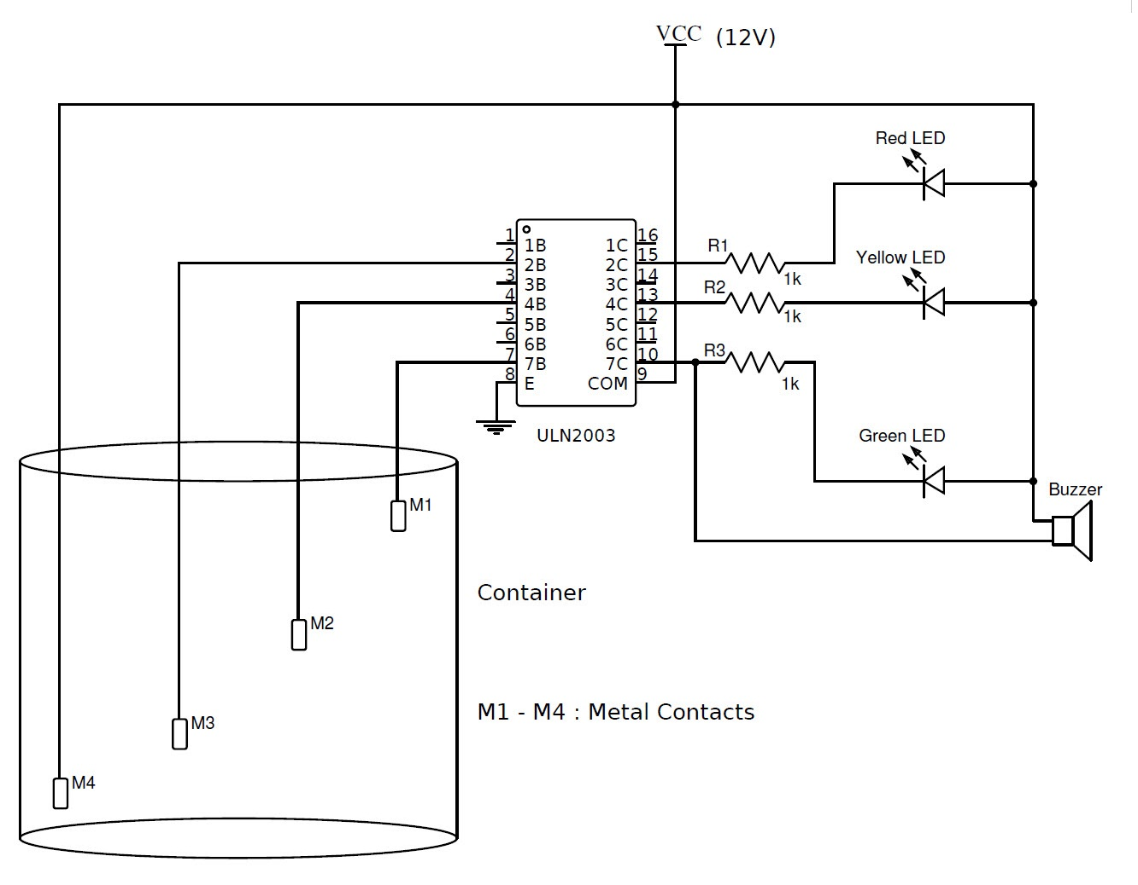

**Components Required**

* L1-L3-LEDs
* R1-R3-1k ohm
* M1-M7-Metal Contacts
* ULN2003 IC

**Working**

* This circuit can be used to indicate three levels of water in tanks.
* When metal contact is reached ,each Led starts glowing.
* When the tank is full buzzer starts ringing along with this all LEDs are ON.